# README for EditUsers Component

The `EditUsers` component is a part of User Management Application designed for managing Users. This README file provides an overview of the code structure and functionality of the `EditUsers` component.

## Overview

The `EditUsers` component allows users to edit User details, including the name, ID, language, and framework of a User. It is intended for use within a larger User management application. Below is an overview of the component's key features and structure.

## Code Structure

### Component Constructor

In the constructor of the component, initial state values are set based on the provided `User` object. The `User` object should contain the User's details, such as `id`, `name`, `language`, and `framework`. If any of these properties are missing, default empty values are assigned. Additionally, the constructor logs the `props.User` object to the console.

### Update Function

The `update` function is triggered when the user submits the form to update User details. It performs the following actions:

- Prevents the default form submission to avoid page reload.

- Validates that all fields (name, ID, language, and framework) are filled in; if any field is empty, an alert is displayed, and the update process is halted.

- Calls the `updateUserhandler` function passed as a prop with the current state (updated User details).

- Clears the form fields by setting their values to empty strings.

### Render Function

The `render` function defines the component's UI. It displays a form with input fields for the User's name, ID, language, and framework. Each input field is controlled by its corresponding state value. When the user types in an input field, the `onChange` event updates the state accordingly.

As when we click on any of the users edit option

Then a new page will be rendered and the id will be there which will not be editable and rest of the details we have to fill and click on the update button to update the user details.

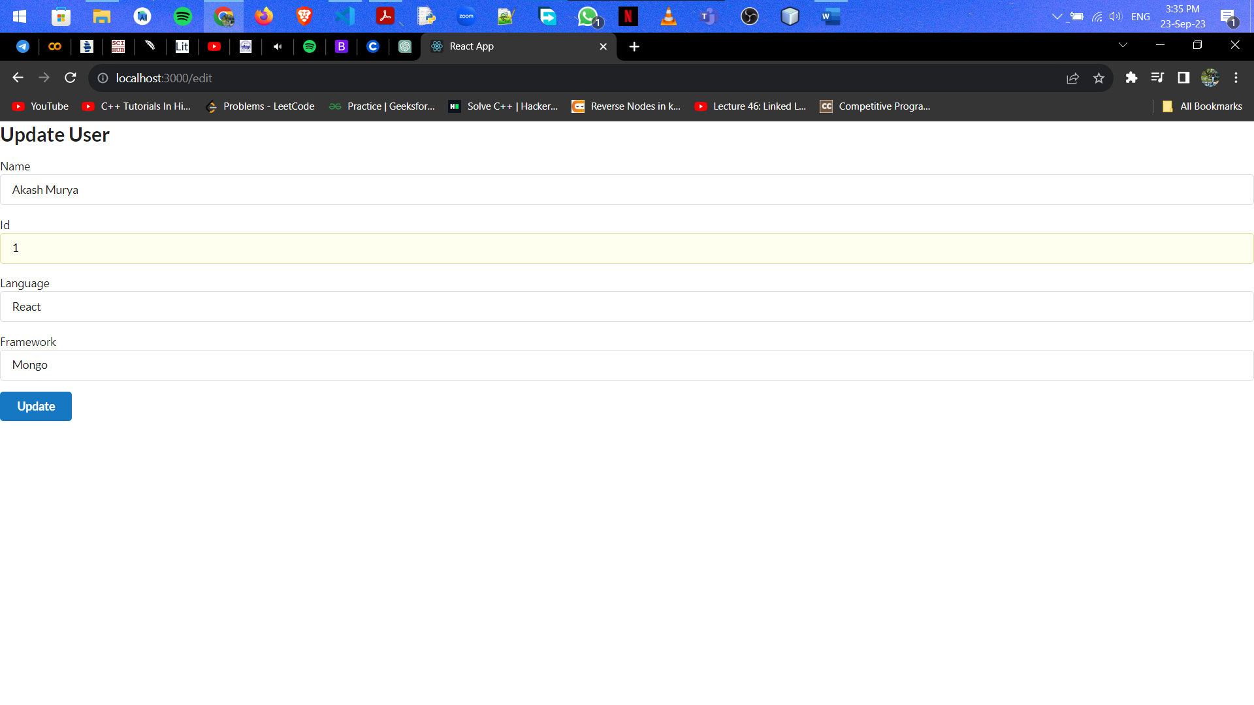

Details which we changed will be reflected in the userlist now.

